SDMP Implementation

# Further Development

The main feature that needs to be developed further is the playlist show/hide function. Currently the playlist slides out from the back of the player for the user to see. This is quite fluid and aesthetically appealing. However, on the closuring the playlist, it simply vanishes. Compared to the smooth sliding transition, this is rather aggressive and isn’t as appealing visually.

# Improvements

When the music player is first loaded, if the playlist is clicked open, the sizing of the section with headers “Track Name” and “Album Name” are not sized appropriately. As per the screenshot below, the headers row should be sized the same as the search bar.

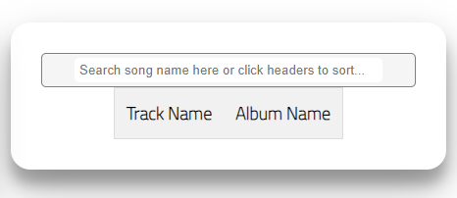

# Maintenance

On regression testing a non-requirement feature, a bug was found. It was noted that if the currently playing track was not the last in the playlist, when a new track was added, the track that played was the track next in the playlist and not the track recently added.

The below logic/sudo-code should help to understand this issue.

X = currently playing track, Y = Total number of tracks in playlist, X < Y

When playing X of Y, adding a new track plays X+1, not Y+1